CPCS 380 Operating System Principles

Final Exam Study Notes

Chapter 1 – Introduction
Know the definition of an operating system
A program that manages a computer’s hardware acting as an intermediary between the computer user and the hardware.
- Resource allocator: manages all resources and decides between conflicting requests for efficient and fair resource use
- Control program: controls execution of programs to prevent errors and improper use of the computer
Familiar with the general system structure
- Hardware
  - Provides basic computing resources
- Operating Systems
  - Controls and coordinates use of hardware among various applications and users
- Application Programs
  - Define the ways in which the system resources are used to solve the computing problems of the users
- Users
  - People, machines, and other computers
Computer startup (i.e. bootstrap programs)
Initializes all aspects of the system, loads operating system kernel and starts execution. Bootstrap is stored in firmware.
Computer system organizations (CPUs, device controllers, bus memory cycles)
Consists of 1 or more CPUs and a number of device controllers connected through a common bus that provides access to main memory. Memory controller synchronizes access to shared memory between the CPUs and device controllers.
Interrupts and Interrupt Handling
Interrupts: transfers control to the interrupt service routine through the interrupt vector which contains addresses of all the service routines. An OS is interrupt driven. Trap/exception is a software-generated interrupt.
Interrupt Handling: OS preserves the state of the CPU by stored registers and the program counter. Determines what type of interrupt occurred (polling or vectored interrupt system).
I/O Structure
- System calls
  - Request to the OS to allow the user to wait for I/O completion
- Device-status tables
  - Contains entry for each I/O device indicating its type, address, and state.
Storage Structure
- Storage Hierarchy
  - 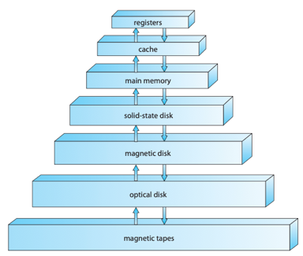
  - Organized by speed, cost, and volatility
- Caching
  - Data stored in main memory is copied into faster memory on a temporary basis for quick access (main memory can be viewed as a cache for secondary storage).
Direct Memory Access Structure
- How DMA works
  - Used for high-speed I/O devices able to transmit information at close to memory speeds
  - Device controller transfers blocks of data from buffer storage directly to main memory without CPU intervention
  - Only one interrupt generated per block
Computer-System Architecture
- Symmetric Multiprocessing Architecture
  - Each processor performs all tasks
  - 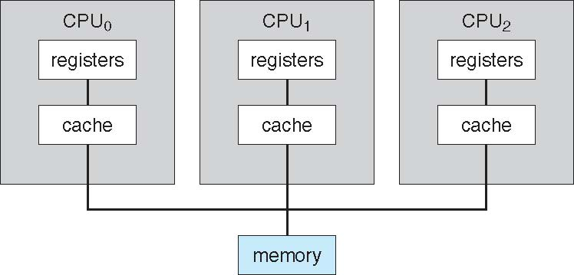
- Dual-Core Design
  - Multi-chip and multicore
  - System containing all chips
  - 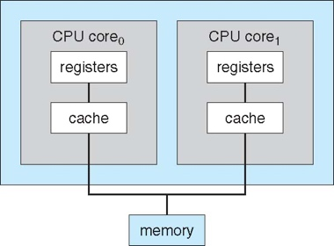
- Clustered Systems
  - Multiple systems working together
    - Usually share storage via SAN (storage-area network)
    - Provides a high-availability service which survives failures
    - Can be used for HPC (high-performance computing)
  - 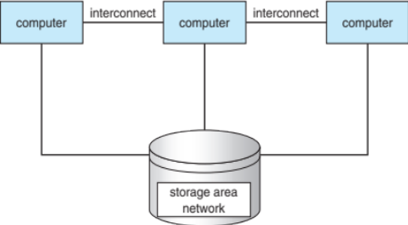
Operating System Structure
- Operating-System Operations
  - Interrupt driven
  - Dual-mode
- Process Management
  - Process is a program in execution
  - Create/delete user/system processes
  - Suspending/resuming processes
  - Allow for process synchronization
  - Allow for process communication
  - Allow for deadlock handling
- Memory Management
  - Determine what is in memory and when
  - Keep track of what memory is being used and by whom
  - Decide which processes and data to move into/out of memory
  - Allocate/deallocate memory space
- Storage Management
  - File-System Management
  - File: abstracts physical properties to logical storage unit
- I/O Subsystem
  - Device-driver interface
  - Memory management of I/O
- Protection & Security
  - Protection: any mechanism for controlling access of processes or users to resources defined by the OS
  - Security: defense of the system against internal/external attack

Chapter 2 – Operating-System Structures
OS Services
- User interface
  - CLI (command-line)
  - GUI (graphical user interface)
  - Batch
- Program execution
  - The system must be able to load a program into memory and run that program and end execution
- I/O operations
  - A running program may require I/O, which may involve a file or I/O device
- File-system manipulation
  - Programs need to read and write files
- Communications
  - Processes may exchange information on the same computer or over a network
- Error Detection
  - OS needs to constantly be aware of possible errors
- Resource allocation
  - Resources must be allocated to multiple users/jobs
- Accounting, Protection and Security
  - Accounting: Keep track of which sers how much and what kinds of resources
  - Protection: ensure access to resources is controlled
  - Security: require user authentication to defend against invalid access
Operating Systems Interface
- CLI or GUI
  - Shells (i.e. csh, bash, …)
  - CLI allows direct command entry
  - GUI is a user-friendly desktop metaphor interface
System Calls/Programs
- APIs
- Application Programming Interface allows access to programs from high-level rather than direct system call use
  - System Call Implementation
    - System-call interface: maintains a table indexed according to a list of numbers associated with each system call
    - System-call interface invokes the intended system call in OS kernel and returns status of the system call

Chapter 3 – Processes
Process Concept
- Text section, data section, program counter, stack, heap
  - Text section: the program code
  - Program counter: contains the address of the current instruction being executed
  - Stack: contains temporary data such as function parameters, return addresses, and local variables
  - Data section: global variables
  - Heap: contains memory dynamically allocated during running time
- Process in memory
  - Stack memory addresses decrease
  - Heap memory addresses increase
  - 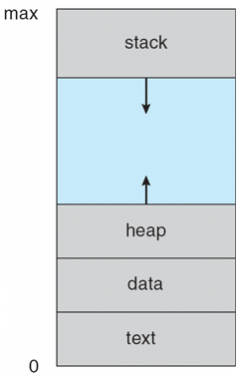
- Process state
  - New: process is being created
  - Running: instructions are being executed
  - Waiting: process is waiting for some event to occur
  - Ready: process is waiting to be assigned to a processor
  - Terminated: process has finished execution
  - 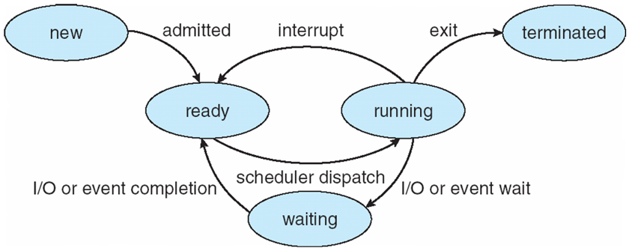
- Process Control Block
  - Data type to store information associated with each process
    - Process state
    - Program Counter
    - CPU registers
    - CPU scheduling information
    - Memory-management information
    - Accounting information
    - I/O status information
- Threads of execution
  - Consider multiple program counters per process, multiple locations can execute at once meaning there are multiple threads of control
Process Scheduling
- Long-term schedulers (job scheduler)
  - Selects which processes should be brought into the read queue
    - Invoked infrequently
    - Controls the degree of multiprogramming
- Short-term schedulers (CPU scheduler)
  - Selects which process should be executed next and allocates CPU
    - Invoked frequently
Context-Switch
Saves the state of an old process and loads the saved state for a new process so that a CPU can switch processes
Context of a process represented in PCB
Creates overhead (no useful work done while switching)
Operation on Processes
- Creation, termination
  - Creation: parent process create children processes, each identified via a process identifier (pid)
  - Termination: process executes last statement and asks OS to delete it using exit()
- Forking processes
Interprocess Communications
- Shared memory
  - Area of memory shared among the process
  - Communication is under user control
  - Synchronization becomes an issue
- Message passing
  - Processes communicate with each other without using shared variables
  - Processes must establish a communication link and exchange messages via send()/receive()
- 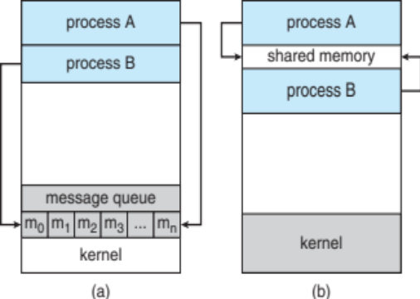
- Independent/Cooperating Processes
  - Independent: process cannot affect or be affected by the execution of another process
  - Cooperating: process can affect or be affected by the execution of another process
- Indirect Communication
  - Mailboxes
    - Has a unique id
    - Process can only communicate if they share a mailbox
- Synchronization
  - Blocking
    - Synchronous
    - Blocking send: sender is blocked until the message is received
    - Blocking receive: receiver is blocked until a message is available
  - Non-blocking
    - Asynchronous
    - Non-blocking send: sender send the message and continues
    - Non-blocking receive: the receiver receives a valid message or a null message
- Buffering
  - Queue of messages attached to the link
- Pipes, Sockets, Remote Procedures Calls (RPCs)
  - Socket: defined as an endpoint for communication
  - Remote Procedure Calls: abstracts procedure calls between processes on networked systems
  - Pipes: acts as a conduit allowing two processes to communicate

Chapter 4 – Threads
Multithreaded Architectures
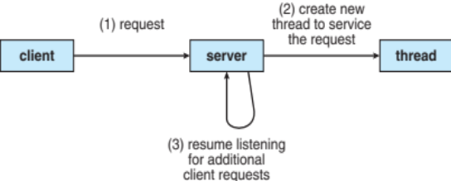
- Benefits
  - Responsiveness: allows continued execution if part of process is blocked
  - Resource Sharing: threads share resources of process (easier than setting up IPC)
  - Economy: cheaper than process creation and thread switching as well as lower overhead than context switching
  - Scalability: process can take advantage of multiple processors
- Multicore programming
  - Challenges
    - Dividing activities
    - Balance
    - Data splitting
    - Data dependency
    - Testing and debugging
  - Parallelism: system can perform more than one task simultaneously
    - Data parallelism: distributes subsets of same data across multiple cores, same operation on each
    - Task parallelism: distributes threads across multiple cores, unique operation with each thread
  - Concurrency: more than one task making progress
  - 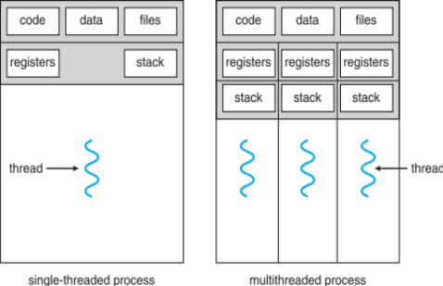
Concurrency/Parallelism
- Amdahl’s Law
  - Identifies gains from adding additional cores to an application that has serial and parallel components
  - 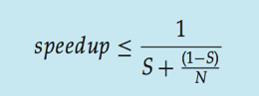
    - S = serial portion
    - N = processing cores
User/Kernel Threads & Multithreading Models
User threads: management done by user-level threads library
Kernel threads: supported by the kernel
- Thread Libraries
  - Provides programmer with API for creating and managing threads
- Pthreads examples
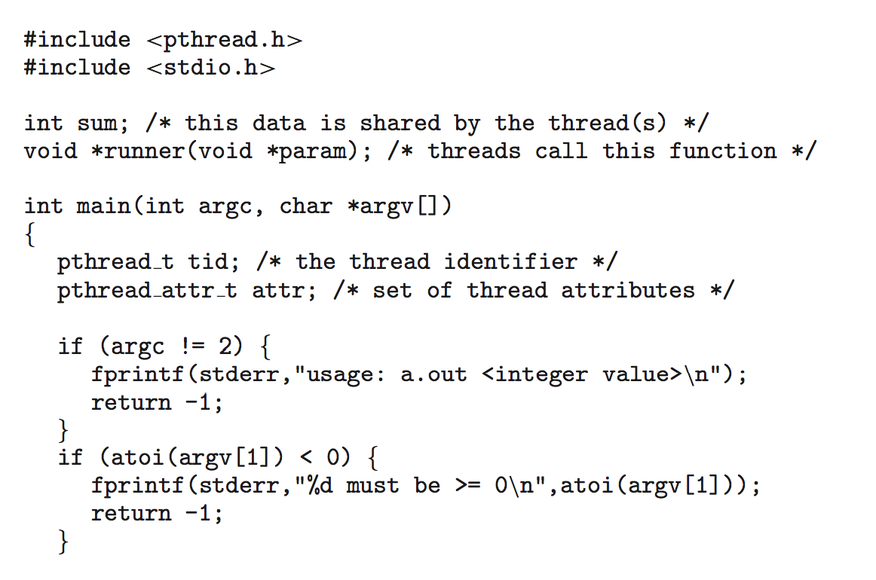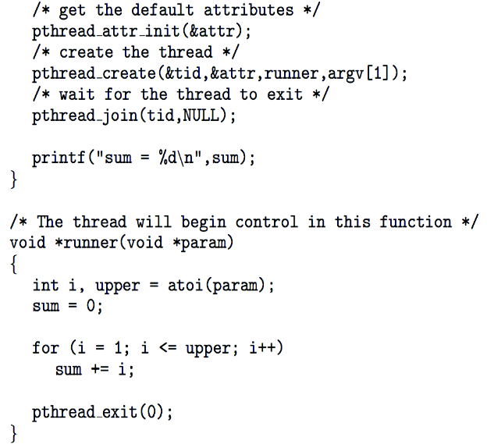
Signal Handling
Signals used to notify a process an event has occurred
Signal handler used to process signals
Thread Cancellation
Terminating a thread before it has finished
Asynchronous cancellation terminates the target thread immediately.
Deferred cancellation allows the target thread to periodically check if it should be cancelled.

Chapter 5 – Process Synchronization

Describe the Critical Section Problem.
Each process must ask permission to enter critical section in entry section, may follow critical section with exit section, then remainder section
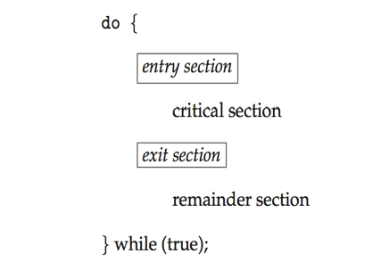
Know the three requirements the critical-section problem must satisfy
- Mutual Exclusion
  - If process in its critical section, then no other processes can be executing their critical sections
- Progress
  - If no process is executing in its critical section and there exist some processes that wish to enter their critical section, then the selection of the processes that will enter the critical section cannot be postponed indefinitely
- Bounded Waiting
  - A bound must exist on the number of times that other processes are allowed to enter their critical sections after a process has made a request to enter its section and before that request is granted

Know the definition of the hardware instructions TestAndSet and Swap
boolean test_and_set (boolean *target)
{
boolean rv = *target;
*target = TRUE;
return rv:
}
do {
while (test_and_set(&lock))
; /* do nothing */
/* critical section */
lock = false;
/* remainder section */
} while (true);
int compare_and_swap(int *value, int expected, int new_value) {
int temp = *value;
if (*value == expected)
*value = new_value;
return temp;
}
do {
while (compare_and_swap(&lock, 0, 1) != 0)
; /* do nothing */
/* critical section */
lock = 0;
/* remainder section */
} while (true);

What is a semaphore? How are the used? How are they implemented?
Synchronization tool that provides more sophisticated ways for process to synchronize their activities.
Integer variable
Accessed through wait() and signal()
Counting semaphore: integer value can range over an unrestricted domain
Binary semaphore: integer value can range only between 0 and 1
Know/Describe some classic problems of synchronization
- Bounded-Buffer Problem
  - n buffers, each can hold one item
  - Semaphore mutex = 1
  - Semaphore full = 0
  - Semaphore empty = n
- Reader-Writers Problem
  - A data set is shared among a number of concurrent processes
  - Readers: can only read from the data set
  - Writers: can read and write
- Dining-Philosophers Problem
  - Philosophers can think and eat
  - Takes 2 chopsticks to eat (access one at a time)
  - Should not interact with neighbors
What are Monitors?
A high-level abstraction that provides a convenient and effective mechanism for process synchronization.
What is an Atomic Transaction?
Atomic = non-interruptible

Chapter 6 – CPU Scheduling
Basic Concepts
- CPU & I/O Bursts
  - Process execution consists of a cycle of CPU execution and I/O wait
CPU Scheduler
- Preemptive/Non-preemptive
  - Non-preemptive: switches from running to waiting state or termination
  - Preemptive: switches from running to ready state or waiting to ready
    - Consider access to shared data
    - Consider preemption while in kernel mode
    - Consider interrupts occurring during crucial OS activities
- Dispatcher
  - Gives control of the CPU to the process selected by the short-term scheduler
    - Switches context
    - Switches to user mode
    - Jumps to proper location in the user program to restart that program
- Scheduling Criteria
  - CPU utilization – keep the CPU as busy as possible
  - Throughput – # of processes that complete their execution per time unit
  - Turnaround time – amount of time to execute a particular process
  - Waiting time – amount of time a process has been waiting in the ready queue
  - Response time – amount of time it takes from when a request was submitted until the first response is produced, not output (for time-sharing environment)
- Scheduling Algorithms
  - FCFS
    - Schedules processes by the order that they arrive in
  - SJF
    - Schedules processes by the order of the processes next CPU burst
  - Priority
    - Schedules processes by a priority number associated with each process
  - RR
    - Each process gets a quantum, after time has elapsed the process is preempted and added to the end of the ready queue
  - Multilevel Queue
    - Ready queue is partitioned into separate queues (foreground and background)
    - Each queue has its own scheduling algorithm (foreground – RR and background – FCFS)
    - 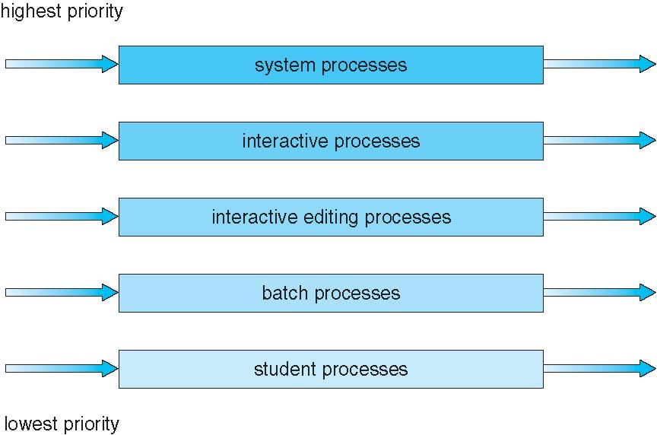
- Multi-Processor Scheduling
  - SMP/AMP
    - Symmetric multiprocessing: each processor is self-scheduling
    - Asymmetric multiprocessing: only one processor accesses the system data structures
  - Soft/Hard Affinity
    - Processor affinity: process has affinity for processor on which it is currently running
    - Soft affinity:
    - Hard affinity:
  - Load balancing
    - Attempts to keep workload evenly distributed
    - Push migration and pull migration
- Real-Time CPU Scheduling
  - Hard/Soft Real-Time systems
    - Soft: no guarantee as to when critical real-time process will be scheduled
    - Hard: task must be serviced by its deadline
  - Rate Monotonic (RM)
    - Priority is assigned based on the inverse of its period
  - Earliest Deadline First (EDF)
    - Priority is assigned according to deadlines

Chapter 7 – Deadlocks

What is deadlock?
A process requests resources; if the resources are not available at that time, the process enters a waiting state. Sometimes, a waiting process is never again able to change state, because the resources it has requested are held by other waiting processes.

Know the conditions necessary for deadlock to hold and what they mean.
- Mutual exclusion. At least one resource must be held in a nonsharable mode; that is, only one process at a time can use the resource. If another process requests that resource, the requesting process must be delayed until the resource has been released.
- Hold and wait. A process must be holding at least one resource and waiting to acquire additional resources that are currently being held by other processes.
- No preemption. Resources cannot be preempted; that is, a resource can be released only voluntarily by the process holding it, after that process has completed its task.
- Circular wait. A set { P0 , P1 , ..., Pn } of waiting processes must exist such that P0 is waiting for a resource held by P1, P1 is waiting for a resource held by P2, ..., Pn−1 is waiting for a resource held by Pn, and Pn is waiting for a resource held by P0.
What is a Resource Allocation Graph (RAG)? What are they used for?
Helps determine if a system is in deadlock graphically

Know the methods for handling deadlock
- Deadlock Prevention
  - Mutual Exclusion
  - Hold and Wait
  - No Preemption
  - Circular Wait
- Deadlock Avoidance
  - Know the definition of a safe state
  - Understand the Resource-Allocation Graph Algorithm
  - Know the Banker’s Algorithm
  - Know the Safety Algorithm
  - Know the Resource-Request Algorithm
- Deadlock Detection
  - Resource Allocation Graph
  - Wait-for-Graph
  - Detection-Algorithm Usage

Know the methods for recovering from deadlock
- Process Termination
  - Abort all processes
  - Abort one process at a time
- Resource Preemption
  - Select a victim
  - Rollback
  - Starvation

Chapter 8 – Main Memory

What is address binding?
Binds instructions and data to memory addresses

Define Logical-Verses-Physical Address Space
Define Dynamic Loading
Describe Dynamic Linking and Shared Libraries
What is an Overlay? How are they used?
Describe/Define Swapping
Describe Contiguous Memory Allocation
What is the purpose of memory protection?

Know the memory allocation techniques
- First Fit
- Best Fit
- Worst Fit
What is memory fragmentation?
- Internal fragmentation
- External fragmentation

What is Paging?
Understand how paging works (basic method)
What is the purpose of the TLB
How is memory protected?
Be familiar with page table structures
- Hierarchical Paging
- Hashed Paging
- Inverted Paging

What is Segmentation? How does it work?

Chapter 9 – Virtual Memory
What is demand paging? What are the basic concepts?
How are page faults handled?
What techniques are used for page replacement? What is the basic scheme?
Know the page replacement algorithms
- FIFO Page Replacement
- Optimal Page Replacement
- LRU Page Replacement

How are memory frames allocated?
Understand the allocation algorithms
- Global Replacement
- Local Replacement

What is thrashing?
What are the causes of thrashing?
Describe the Working-Set model

Chapter 10 – Mass Storage Structure
Overview Terms
Magnetic Disks
  - Understand Transfer Rate
  - What is Positioning Times
  - What is a Head Crash
Know the various I/O Busses
EIDE, ATA, SATA, USB, Fibre Channel, SCSI, SAS, Firewire

Calculate Hard-Disk Performance

Understand Storage Area Networks and Network-Attached Storage

Disk Scheduling

- Know and be able to calculate the total head movements for the various disk scheduling algorithms
  - FCFS
  - SSTF
  - SCAN/C-SCAN
  - C-LOOK

Understand Disk Management

- Formatting
  - Low-level or physical
  - Partitioning
  - Logical formatting
- Boot Block
  - Bootstrap loader
  - Master Boot Record

Raid Structures
- Striping, Mirroring, replication
- RAID levels

Chapter 11 – File System Interface
File Concept
- Familiar with File Attributes types
- Understand the details of File Operations
  - Create, Open, Close Write, Read, Delete, …
- Know various types of file structure

Access Methods
- Sequential Access
- Direct Access
- Other Access methods – Index and Relative Files

Disk and Disk Directory Structure
- Understand the disk structures
  - Partitions, raw, formatted, volumes
- Familiar with Directory Organization
  - Single-level
  - Two-Level
  - Tree-Structured
  - Acyclic-Graph
  - General-Graph
  - File-System Mounting
File Sharing
- Understand File sharing in a multi-user system
- Identify some Remote File Sharing methods

Protection
- Identify the various types of file access.
  - Read, write, execute, delete, list, …

- Understand about Access List and Groups in a Linux/Unix Env.

Chapter 12 – File System Implementation

File-System Structure
- Be familiar with the various structures
  - File control blocks, disk blocks and sectors and device control

- Know the File System Layers
  - Device drivers, basic file systems, file organization module, logical file systems

File-System Implementation
- Boot/Volume control blocks, File Control Blocks
- Identify In-Memory File System Structures

Allocation Methods
- Be able to identify the various allocation methods and understand the advs/disadvs of each
  - Contiguous, Linked, Indexed

Free-Space Management
- Understand/Explain the free-space list
  - Bit vector or map
  - Linked free space

Chapter 13 – I/O Systems
I/O Hardware
- Identify the variety of I/O devices
  - Ports, Busses, Controllers, …
- Understand the difference between polling and interrupts the advs/disadvs of each

Application I/O Interface
- Understand the difference between stream of block devices
- Identify sequential or random access devices
- Understand the difference between synchronous or asynchronous

Kernel I/O Subsystem
- Understand the Kernel I/O Structure
  - Separation between hardware and software
  - Characteristics of I/O devices
  - Block/Character devices
  - Network devices
  - Clocks ad Timers
  - Nonblocking and asynchronous I/O

- What is the Device-Status Table

Chapter 14- Protection

Goals of Protection
- Name the various protection model goals

Principles of Protection
- Understand the Guiding principle or protection
  - Understand the principle of least privilege

Access Control
- What is Access control and how is it used?
  - What is an access matrix?
  - How is an access matrix implemented?

Capability-Based Systems
- What is a capability-based systems and how does it differ from an access based system?

Chapter 15 – Security

The Security Problem
- Name and defined the various security problems
  - Intruders
  - Threats
  - Attacks
- Identify the various security violation methods
  - Masquerading
  - Replay attack
  - Man-in-the-middle attack
  - Session hijacking
- Identify the various security measure levels

Program Threats
- Identify Program threats (Trojan Horse, Trap Door, Logic Bombs, Buffer Overflow, Viruses)

System and Network Threats
- Identify system or network threats
  - What is a worm? (Morris Worm)
  - What is port scanning
  - What is denial of service

Security Tools
- Be able to identify various security tools (.i.e. encryption)

Practice Exercises
Chapter 1

- What are the three main purposes of an operating system?
  - Execute user programs and make solving user problems easier
  - Make the computer system convenient to use
  - Use the computer hardware in an efficient manner

- Keeping in mind the various definitions of operating system, consider whether the operating system should include applications such as Web browsers and mail programs. Argue both that it should and that it should not, and support your answers.
  - An argument in favor of including popular applications with the operating system is that if the application is embedded within the operating system, it is likely to be better able to take advantage of features in the kernel and therefore have performance advantages over an application that runs outside of the kernel. Arguments against embedding applications within the operating system typically dominate however: (1) the applications are applications - and not part of an operating system, (2) any performance benefits of running within the kernel are offset by security vulnerabilities, (3) it leads to a bloated operating system.

- How does the distinction between kernel mode and user mode function as a rudimentary form of protection (security) system?
  - The distinction between kernel mode and user mode provides a rudimentary form of protection in the following manner. Certain instructions could be executed only when the CPU is in kernel mode. Similarly, hardware devices could be accessed only when the program is executing in kernel mode. Control over when interrupts could be enabled or disabled is also possible only when the CPU is in kernel mode. Consequently, the CPU has very limited capability when executing in user mode, thereby enforcing protection of critical resources.

- Give two reasons why caches are useful. What problems do they solve? What problems do they cause? If a cache can be made as large as the device for which it is caching (for instance, a cache as large as a disk), why not make it that large and eliminate the device?
  - Caches are useful when two or more components need to exchange data, and the components perform transfers at differing speeds. Caches solve the transfer problem by providing a buffer of intermediate speed between the components. If the fast device finds the data it needs in the cache, it need not wait for the slower device. The data in the cache must be kept consistent with the data in the components. If a component has a data value change, and the datum is also in the cache, the cache must also be updated. This is especially a problem on multiprocessor systems where more than one process may be accessing a datum. A component may be eliminated by an equal-sized cache, but only if: (a) the cache and the component have equivalent state-saving capacity (that is, if the component retains its data when electricity is removed, the cache must retain data as well), and (b) the cache is affordable, because faster storage tends to be more expensive.

- Distinguish between the client–server and peer-to-peer models of distributed systems.
  - The client-server model firmly distinguishes the roles of the client and server. Under this model, the client requests services that are provided by the server. The peer-to-peer model doesn’t have such strict roles. In fact, all nodes in the system are considered peers and thus may act as either clients or servers—or both. A node may request a service from another peer, or the node may in fact provide such a service to other peers in the system. For example, let’s consider a system of nodes that share cooking recipes. Under the client-server model, all recipes are stored with the server. If a client wishes to access a recipe, it must request the recipe from the specified server. Using the peer-to-peer model, a peer node could ask other peer nodes for the specified recipe. The node (or perhaps nodes) with the requested recipe could provide it to the requesting node. Notice how each peer may act as both a client (it may request recipes) and as a server (it may provide recipes).

Chapter 2

- What is the purpose of system calls?
  - System calls allow for user access into the operating system without causing file corruption.

- What are the five major activities of an operating system with regard to process management?
  - The creation and deletion of both user and system processes
  - The suspension and resumption of processes
  - The provision of mechanisms for process synchronization
  - The provision of mechanisms for process communication
  - The provision of mechanisms for deadlock handling

- What is the purpose of the command interpreter? Why is it usually separate from the kernel?
  - The command interpreter allows users to directly enter commands to be performed by the operating system. Its main function is to get and execute the next user-specified command. It is normally separate from the kernel since the command interpreter is subject to changes.

- What is the purpose of system programs?
  - System programs can be thought of as bundles of useful system calls. They provide basic functionality to users so that users do not need to write their own programs to solve common problems.

- Why do some systems store the operating system in firmware, while others store it on disk?
  - For certain devices, such as handheld PDAs and cellular telephones, a disk with a file system may be not be available for the device. In this situation, the operating system must be stored in firmware.

Chapter 3

- The Sun UltraSPARC processor has multiple register sets. Describe what happens when a context switch occurs if the new context is already loaded into one of the register sets. What happens if the new context is in memory rather than in a register set and all the register sets are in use?
  - The CPU current-register-set pointer is changed to point to the set containing the new context, which takes very little time. If the context is in memory, one of the contexts in a register set must be chosen and be moved to memory, and the new context must be loaded from memory into the set. This process takes a little more time than on systems with one set of registers, depending on how a replacement victim is selected.

- When a process creates a new process using the fork() operation, which of the following state is shared between the parent process and the child process?
- Stack
- Heap
- Shared Memory

- Original versions of Apple’s mobile iOS operating system provided no means of concurrent processing. Discuss three major complications that concurrent processing adds to an operating system.
  - As multiple processes are concurrently running on the system, the operating system requires keeping track of all the storage space addressed on main memory to prevent on process from mixing with another or using the information stored for any other running process.
  - Context switching between two simultaneous processes requires enough time to locate and maintain register values for program running. A continuous communication between operating system and program control block may overload the system.
  - Process that requires big data blocks for execution may enter deadlocks in wait of getting resources freed up by other processes.

- With respect to the RPC mechanisms, consider the “exactly once” semantic. Does the algorithm for implementing this semantic execute correctly even if the ACK message back to the client is lost due to a network problem? Describe the sequence of messages and discuss whether “exactly once” is still preserved.
  - The “exactly once” semantics ensure that a remote procedure will be executed exactly once and only once. The general algorithm for ensuring this combines an acknowledgment (ACK) scheme combined with timestamps (or some other incremental counter that allows the server to distinguish between duplicate messages). The general strategy is for the client to send the RPC to the server along with a timestamp. The client will also start a timeout clock. The client will then wait for one of two occurrences: (1) it will receive an ACK from the server indicating that the remote procedure was performed, or (2) it will time out. If the client times out, it assumes the server was unable to perform the remote procedure so the client invokes the RPC a second time, sending a later timestamp. The client may not receive the ACK for one of two reasons: (1) the original RPC was never received by the server, or (2) the RPC was correctly received—and performed—by the server but the ACK was lost. In situation (1), the use of ACKs allows the server ultimately to receive and perform the RPC. In situation (2), the server will receive a duplicate RPC and it will use the timestamp to identify it as a duplicate so as not to perform the RPC a second time. It is important to note that the server must send a second ACK back to the client to inform the client the RPC has been performed.

Chapter 4

- Provide three programming examples in which multithreading provides better performance than a single-threaded solution.
  - A Web server that services each request in a separate thread.
  - A parallelized application such as matrix multiplication where different parts of the matrix may be worked on in parallel.
  - An interactive GUI program such as a debugger where a thread is used to monitor user input, another thread represents the running application, and a third thread monitors performance.

- Describe the actions taken by a kernel to context-switch between kernel level threads.
  - Context switching between kernel threads typically requires saving the value of the CPU registers from the thread being switched out and restoring the CPU registers of the new thread being scheduled

- What are two differences between user-level threads and kernel-level threads? Under what circumstances is one type better than the other?
  - User-level threads are unknown by the kernel, whereas the kernel is aware of kernel threads.
  - On systems using either M:1 or M:N mapping, user threads are scheduled by the thread library and the kernel schedules kernel threads.
  - Kernel threads need not be associated with a process whereas every user thread belongs to a process. Kernel threads are generally more expensive to maintain than user threads as they must be represented with a kernel data structure.

- What resources are used when a thread is created? How do they differ from those used when a process is created?
  - Because a thread is smaller than a process, thread creation typically uses fewer resources than process creation. Creating a process requires allocating a process control block (PCB), a rather large data structure. The PCB includes a memory map, list of open files, and environment variables. Allocating and managing the memory map is typically the most time-consuming activity. Creating either a user or kernel thread involves allocating a small data structure to hold a register set, stack, and priority.

Chapter 5

- What is the meaning of the term busy waiting? What other kinds of waiting are there in an operating system? Can busy waiting be avoided altogether? Explain your answer.
  - Busy waiting means that a process is waiting for a condition to be satisfied in a tight loop without relinquishing the processor. Alternatively, a process could wait by relinquishing the processor, and block on a condition and wait to be awakened at some appropriate time in the future. Busy waiting can be avoided but incurs the overhead associated with putting a process to sleep and having to wake it up when the appropriate program state is reached.

- Explain why spinlocks are not appropriate for single-processor systems yet are often used in multiprocessor systems.
  - Spinlocks should not be used for single-processor systems since the condition to break a process out of a spinlock can be obtained only by executing another process. If the process does not permit other programs to run on the processor, there is no way for the process to break out of the spinlock. However, in a multiprocessor system, other processes can execute in parallel on other processors and therefore are able to release the first process from the spinlock.

- Show that, if the wait() and signal() semaphore operations are not executed atomically, then mutual exclusion may be violated.
  - A wait operation atomically decrements the value associated with a semaphore. If two wait operations are executed on a semaphore when its value is 1, if the two operations are not performed atomically, then it is possible that both operations might proceed to decrement the semaphore value, thereby violating mutual exclusion.

- Illustrate how a binary semaphore can be used to implement mutual exclusion among n processes.
  - The n processes share a semaphore, mutex, initialized to 1. Each process Pi is organized as follows:
    - do {
      - wait(mutex);
      - /* critical section */
      - signal(mutex);
      - /* remainder section */
    - } while (true);

Chapter 6

- Explain the difference between preemptive and non-preemptive scheduling.
  - Preemptive scheduling allows a process to be interrupted in the midst of its execution, taking the CPU away and allocating it to another process. Non-preemptive scheduling ensures that a process relinquishes control of the CPU only when it finishes with its current CPU burst.

- What advantage is there in having different time-quantum sizes at different levels of a multilevel queueing system?
  - Processes that need more frequent servicing, for instance, interactive processes such as editors, can be in a queue with a small-time quantum. Processes with no need for frequent servicing can be in a queue with a larger quantum, requiring fewer context switches to complete the processing, and thus making more efficient use of the computer.

- Suppose that a scheduling algorithm (at the level of short-term CPU scheduling) favors those processes that have used the least processor time in the recent past. Why will this algorithm favor I/O-bound programs and yet not permanently starve CPU-bound programs?
  - It will favor the I/O-bound programs because of the relatively short CPU burst request by them; however, the CPU-bound programs will not starve because the I/O-bound programs will relinquish the CPU relatively often to do their I/O.

- Distinguish between PCS and SCS scheduling.
  - PCS scheduling is done local to the process. It is how the thread library schedules threads onto available LWPs. SCS scheduling is the situation where the operating system schedules kernel threads. On systems using either many-to-one or many-to-many, the two scheduling models are fundamentally different. On systems using one-to-one, PCS and SCS are the same.

Chapter 7

- List three examples of deadlocks that are not related to a computer system environment.
2 cars driving on a single lane street from opposite directions

- Suppose that a system is in an unsafe state. Show that it is possible for the processes to complete their execution without entering a deadlock state.
Being in an unsafe state does not guarantee deadlock. The reason for this is because it is possible for a process to release its resources before requesting any further.

- Is it possible to have a deadlock involving only one single-threaded process? Explain your answer.
No, if there’s only one process it won’t ever be in a position where its waiting for another resource from another process.

Chapter 8

- Name two differences between logical and physical addresses.
Logical addresses refer to an abstract address in an abstract address space while physical addresses refer to the actual addresses in memory. Logical addresses are generated by the CPU and translated by MMU (which means physical addresses are generated by the MMU).

- Why are page sizes always powers of 2?
Page addresses are broken up into a page and offset number. It is far easier and more efficient to represent the address using bits so that no arithmetic operations need to be performed to know the value of the offset and page.

- Consider a logical address space of 64 pages of 1024 words each, mapped onto a physical memory of 32 frames.

  - How many bits are there in the logical address?
16 bits
  - How many bits are there in the physical address?
15 bits

- What is the effect of allowing two entries in a page table to point to the same page frame in memory? Explain how this effect could be used to decrease the amount of time needed to copy a large amount of memory from one place to another. What effect would updating some byte on the one page have on the other page?
This allows multiple users to share both code and data. Assuming the code is reentrant, space can be saved through the shared use large programs. “Copying” large amounts of memory could be effected by having different page tables point to the same memory location If code is nonreetrant, modifications from one user would be reflected in the other user’s copy.

Chapter 9

- Under what circumstances do page faults occur? Describe the actions taken by the operating system when a page fault occurs.
Page faults occur when the user attempts to access a page that has not been brought into main memory. The OS checks to make sure the memory access is valid (aborting otherwise). If valid, I/O is requested to write the needed page into a free frame. The page table and process table are then updated and the access is completed.

- Discuss the hardware support required to support demand paging.
The page table needs to be consulted for every memory-access operation and whether the program has read/write privileges for accessing the page (performed in hardware).

- Consider the following page-replacement algorithms. Rank these algorithms on a five-point scale from “bad” to “perfect” according to their page-fault rate. Separate those algorithms that suffer from Belady’s anomaly from those that do not.

  - LRU replacement
  - FIFO replacement
  - Optimal replacement
  - Second-chance replacement
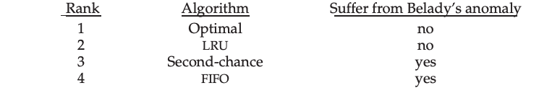

Chapter 10

- Is disk scheduling, other than FCFS scheduling, useful in a single-user environment? Explain your answer.
For a single-user environment, the I/O queue is normally empty. As such, FCFS is performs better in this case. However, given multiple concurrent processes, LOOK will provide far better performance.

- Explain why SSTF scheduling tends to favor middle cylinders over the innermost and outermost cylinders.
The center of the disk is the location having the smallest average distance to all other tracks. Therefore, the disk head tends to move toward the center of the disk.

- Could a RAID level 1 organization achieve better performance for read requests than a RAID level 0 organization (with nonredundant striping of data)?
Yes, a RAID Level 1 organization could achieve better performance for read requests. When a read operation is performed, a RAID Level 1 system can decide which of the two copies of the block should be accessed to satisfy the request. This choice could be based on the current location of the disk head and could therefore result in performance optimizations by choosing a disk head that is closer to the target data.

- Why is it important to balance file system I/O among the disks and controllers on a system in a multitasking environment?
A system can perform only at the speed of its slowest bottleneck. By balancing I/O among disks/controllers, neither the disk nor controller is overwhelmed.

Chapter 11

- Why do some systems keep track of the type of a file, while others leave it to the user and others simply do not implement multiple file types?
Some systems allow different file operations based on the type of the file (for instance, an ascii file can be read as a stream while a database file can be read via an index to a block). Other systems leave such interpretation of a file’s data to the process and provide no help in accessing the data. The method that is “better” depends on the needs of the processes on the system, and the demands the users place on the operating system. If a system runs mostly database applications, it may be more efficient for the operating system to implement a databasetype file and provide operations, rather than making each program implement the same thing (possibly in different ways). For generalpurpose systems it may be better to only implement basic file types to keep the operating system size smaller and allow maximum freedom to the processes on the system.

- Explain the purpose of the open() and close() operations.
Open() informs the system that the file is about to become active
Close() informs the system that the file is no longer active

- Consider a system that supports 5,000 users. Suppose that you want to allow 4,990 of these users to be able to access one file. How would you specify this protection scheme in Linux.
Put the 4,990 users in a group and set their access accordingly.

Chapter 12

- What problems could occur if a system allowed a file system to be mounted simultaneously at more than one location?
There would be multiple paths to the same file (which is confusing and encourages mistakes).

- Why must the bitmap for file allocation be kept on mass storage, rather than in main memory?
Allows the free-space list to not be lost in case of a system crash.

- Consider a system that supports the strategies of contiguous, linked, and indexed allocation. What criteria should be used in deciding which strategy is best utilized for a particular file?
Contiguous – file is usually access sequentially and is relatively small
Linked – if file is large and usually accessed sequentially
Indexed – if file is large and usually accessed randomly

Chapter 13

- State three advantages of placing functionality in a device controller, rather than in the kernel. State three disadvantages.
Advantages: Bugs less likely to crash system, improved performance by using dedicated hardware/hard-coded algorithms, kernel is simplified
Disadvantages: Bugs are harder to fix, modifying algorithms requires a hardware update, embedded algorithms can conflict with application’s use which decreases performance

- Why might a system use interrupt-driven I/O to manage a single serial port and polling I/O to manage a front-end processor?
Polling is efficient when I/O is frequent and of short duration. As such, since front-end processors require frequent I/O operations polling would be more effective (using interrupt driven would result in a heavy load on the system). Single serial ports on the other hand perform I/O relatively infrequently, meaning interrupts should be used.

- How does DMA increase system concurrency? How does it complicate hardware design?
DMA allows the CPU to perform tasks while the DMA system transfers data via the system/memory buses. This complicates the hardware design since the DMA controller must be integrated into the system and should be a bus master.

- Why is it important to scale up system-bus and device speeds as CPU speed increases?
Generally, we should remove the current system bottleneck by increasing overall system performance rather than increasing individual system components.

Chapter 14

- What are the main differences between capability lists and access lists?
Capability Lists: A list of objects and operations allowed on those objects for each domain.
Access Lists: A list for each object consisting of the domains with a nonempty set of access rights for that object.

- What protection problems may arise if a shared stack is used for parameter passing?
The contents of the stack can be compromised by other processes sharing the stack.

- Why is it difficult to protect a system in which users are allowed to do their own I/O?
I/O requires accessing the hardware and proper access is required for system integrity. If I/O access by the user is performed in kernel-mode the system’s integrity cannot be guaranteed.

Chapter 15

- Buffer-overflow attacks can be avoided by adopting a better programming methodology or by using special hardware support. Discuss these solutions.
One form of hardware support that guarantees that a buffer overflow attack does not take place is to prevent the execution of code that is located in the stack segment of a process’s address space. Another approach is to program in languages that checks the bounds of a buffer (such as Java).

- What are two advantages of encrypting data stored in the computer system?
Provides security to data and it protects privacy

- What commonly used computer programs are prone to man-in-the middle attacks?
Any protocol that requires a sender and a receiver to agree on a session key before they start communicating is prone to the man-in-the-middle attack. For instance, if one were to implement on a secure shell protocol by having the two communicating machines to identify a common session key, and if the protocol messages for exchanging the session key is not protected by the appropriate authentication mechanism, then it is possible for an attacker to manufacture a separate session key and get access to the data being communicated between the two parties. In particular, if the server is supposed to manufacture the session key, the attacker could obtain the session key from the server, communicate its locally manufactured session key to the client,

